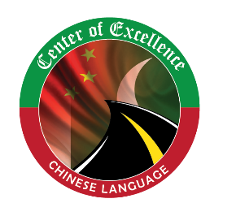

CENTER OF EXCELLENCE, CHINESE LANGUAGE

Picture
With White Background
REGISTRATION FORM
FOR HSK-I
CHINESE LANGUAGE DIPLOMA
22nd July – 22nd Oct, 2019

Student Name:
Father Name :
Student Contact #
Landline/Mobile #
Emergency Contact #
Father/Mother / Guardian
EMAIL ID
Father CNIC#
Student CNIC #
Occupation
Organization Name
Faculty
Registration #
Semester
Home Address
Company /Job Address
Section: A(HSK-I) B(HSK-I) C(HSK-I) D(HSK-I)

Required Documents
- *Attach 2 passport size pictures with white background.
- *A copy of CNIC/B-from
- *Send your Scan Passport size picture with white background and Scan CNIC at rabia.younas@ucp.edu.pk.

Read the instruction carefully before signing the Registration form.

Instructions
- UCP HSK-I Registration fee is 7,000/-
- Form will not be acceptable if the required document will not attached.
- Scan Picture size should be less than 100KB and Resolution should be 180*240pxls in JPG format.
- In diploma program Quiz, Assignments final projects Midterm exam Attendance and Class participation Marks will be included in the final result.
- According to UCP, Chinese Diploma Minimum passing percentage is 60%.
- For Selection of International Certification (Official registration of HANBAN Testing Center, china) 80% marks are Mandatory for Midterms and Finals.
- After Selection UCP will help the students for online registration and Students will submit registration fee 1050/-for international certification in Confucius institute Punjab University Lahore.
- Official test passing % age is Also 60%.
- Confucius fee is not included in 7000/-

Date: __________________ Applicant Signature: _____________

